Dual Switch Controller Procedure
Below are some steps to take and settings to look for when operating a Dual Switch Controller. These include initial start up steps, factory default settings, and reboot procedures.
- Start Up
  - After applying power to the controller, you should see the touch screen in the panel turn on. If the touch screen does not come on, then the controller is not powering up. Check the fuse located in the housing of the power outlet on the controller. There is a spare fuse there if it is necessary.
  - The screen will display the words “Dual Switch Controller” at the top followed by a label in the corner showing “*00FF” (See Picture Below). This is normal for startup and after 1-2 minutes the system should be fully booted up and ready to use.
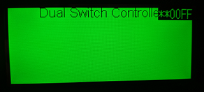
  - If after the 1-2-minute boot time you do not see the screen change from the description listed above, then there may be a problem and the manufacturer should be contacted. AEC Engineering, Inc. (207) 865-4190

- Factory Default Settings
  - The Dual Switch Controller comes preloaded from the manufacturer with initial settings in place. These settings should be confirmed before any outside equipment is attached to the controller. The settings included are switch labels, alarm enables, load interlock enables, load interlock delays, control voltage, and IP address.
  - The default settings for the switch labels are pictured below for both switch 1 and switch 2.
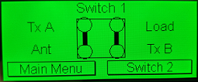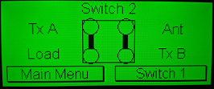
  - The default settings for the alarm enables is “Disabled” (See Page 16 of manual).
  - The default settings for the load interlock enables is “Disabled” (See Page 20 of manual).
  - The default settings for the load interlock delays is 2 seconds (See Page 20 of manual).
  - The default setting for control voltage is 12v Control (See Page 21 of manual.
  - The IP address initial settings are on page 19 of the manual.

- Reboot Procedures
  - The system will automatically reboot the controller whenever the IP address is changed and confirmed.
  - When the system is rebooting the touch screen will become unresponsive. This is normal. The controller is rebooting to apply the IP address change and no touch screen functions will work for a 1-2-minute period.
  - To confirm the IP address change once the reboot is finished you should leave the IP address menu and then return to the IP address menu, as it may not show your changes until the information is refreshed.

